Sports editor
The sports editor is for team managers to enter details of their team, and all related activities. The users can access via web or via an app.

Use cases
These are the use cases for the editor.
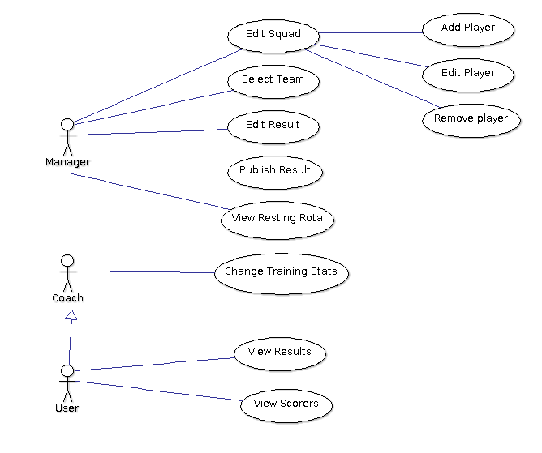

Concepts
The squad is a list of players available for playing fixtures.
The team for a particular fixture is a list of the selected players, plus subs.
There will be plug-ins for particular sports.

Use cases

Edit Squad
The manager role can edit the squad, they will do that to add, edit and delete players. The squad is the list of players that are eligible to play in a competition. Each player can be specified to eligible for each competition. There will be multiple competitions.

Add player
Inserts a new player into the squad.

Edit player
Allows the players details to be altered.

Remove player
Deletes a player from the squad, thereby making them unavailable for future matches. Historical records for the player need to be kept.

Select team
For a fixture, the manager will pick a team. The manager will be shown a list of players. In the list of players, each player will have a recent history of whether they played, rested or were unavailable.

Edit Result
After a match has been played, the manager fills in the result. The type of entry is dependent upon the sport. Substitutions can also be entered, depending on the sport. The result, and other details, can be edited until the result is published.

Publish Result
When the result is finalised, the result can then be published. It can be published to the league via the league's api settings, or by email. The result will also be emailed out to the other members of the club.

View resting rota
So that the manager can work out who to rest, they can view the resting history from a team perspective.

